Databases 1 ERD and SQL Assignment

# ERD

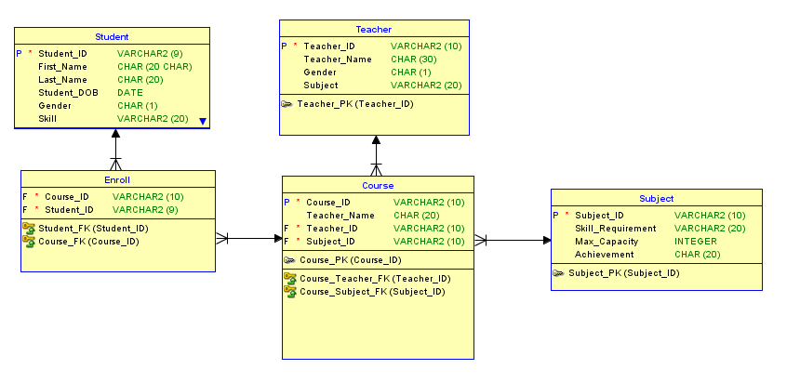

In my ERD for the Coder Camp I have 5 entities, Student, Enrol, Course, Teacher and Subject.

The student, teacher and subject entities contain the basic information about themselves and having their own Id as a primary key. The course entity takes the teacher id and subject id as foreign keys and provides the enrol entity its course id as a foreign key. The enrol entity also gets the student id as a foreign key.

Student can enrol in many courses, teachers teach many courses and courses contain many subjects.

# Transactions and Queries

I didn’t understand how to do transactions so I rushed it at the end and did the bare minimum, I deleted, added and altered pieces from the tables.

For the Queries I simply just displayed the tables.